**PRACTICAL NO.7**

**AIM:-JOIN QUERIES**

**INNER JOIN**

**OUTER JOIN**

**Create table query**

create table supplier

(sid tinyint primary key,

Sname varchar(25),

Address varchar(25)

);

Table created

**Insert value query**

insert into supplier values

(1,’ABC’,’Andheri’);

1row created.

insert into supplier values

(2,’PQR’,’Malad’);

1row created.

insert into supplier values

(2,’PQR’,’Malad’);

1row created.

insert into supplier values

(3,’XYZ’,’Virar’);

1row created.

insert into supplier values

(4,’EFG’,’Kandivali’);

1row created.

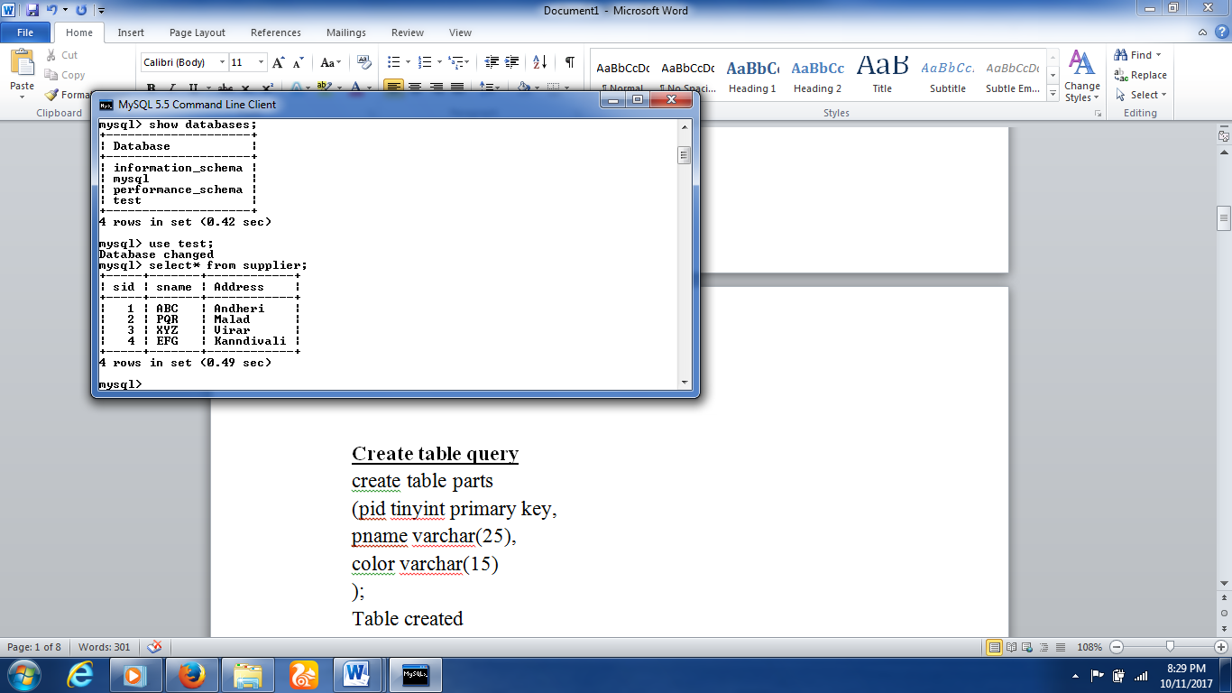

**Create table query**

create table parts

(pid tinyint primary key,

pname varchar(25),

color varchar(15)

);

Table created

**Insert value query**

insert into parts values

(11,’Monitor’,’Red’);

1 row created.

insert into parts values

(12,’Keyboard’,’Black’);

1 row created.

insert into parts values

(13,’Mouse’,’Red’);

1 row created.

insert into parts values

(14,’CPU’,’White’);

1 row created.

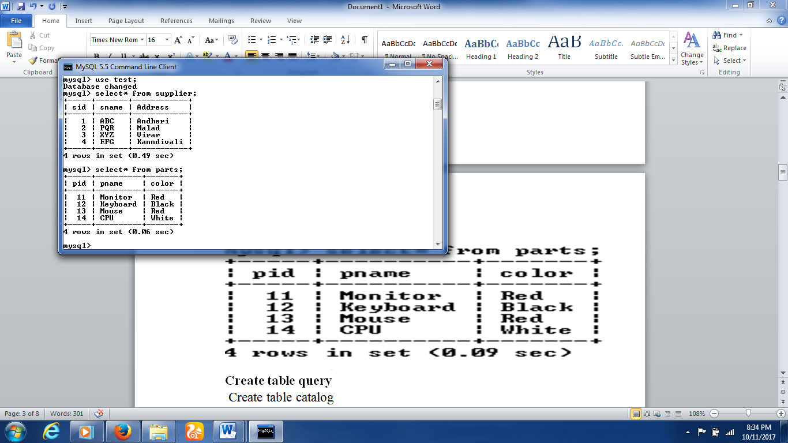

**Create table query**

Create table catalog

(sid tinyint references supplier(sid),

pid tinyint references parts(pid),

cost int

);

Table created

**Insert query**

insert into catalog values

(1,11,1000);

1row craeted.

insert into catalog values

(1,13,2000);

1row craeted.

insert into catalog values

(2,12,350);

1row craeted.

insert into catalog values

(3,13,2200);

1row craeted.

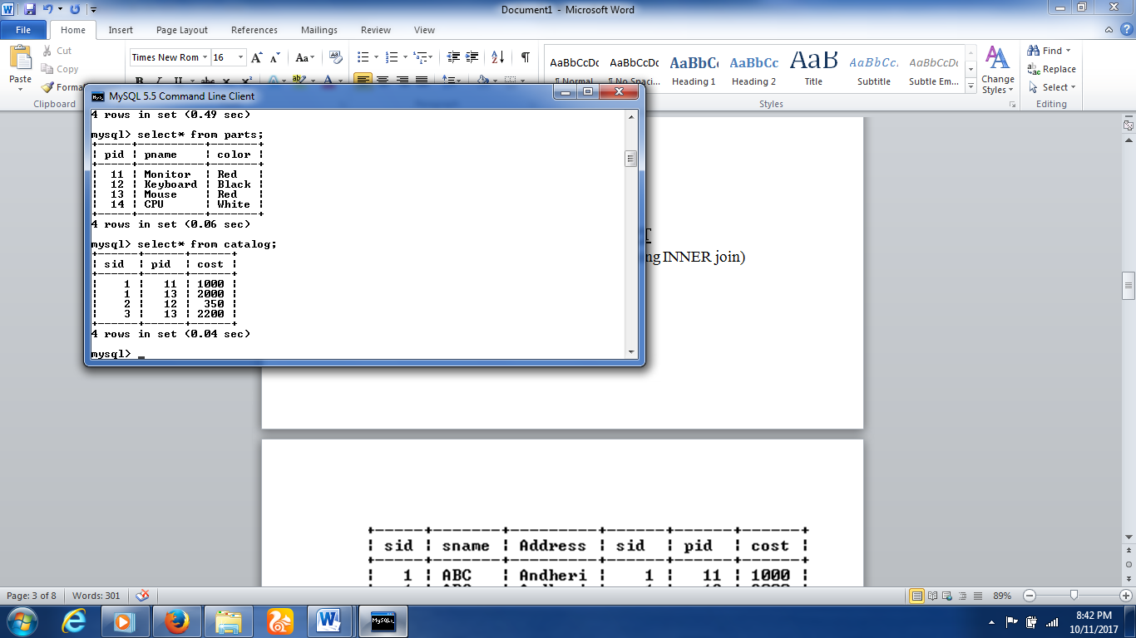

**Que No.1:-DEMONSTRATE JOIN CONCEPT**

1)Join supplier table with catalog table .(using INNER join)

QUERY

Select* from supplier

INNER JOIN

catalog ON supplier.sid=catalog.sid;



2)Join parts table with catalog table. (using INNER join)

QUERY

Select* from parts

INNER JOIN

Catalog ON parts.pid=catalog.sid;

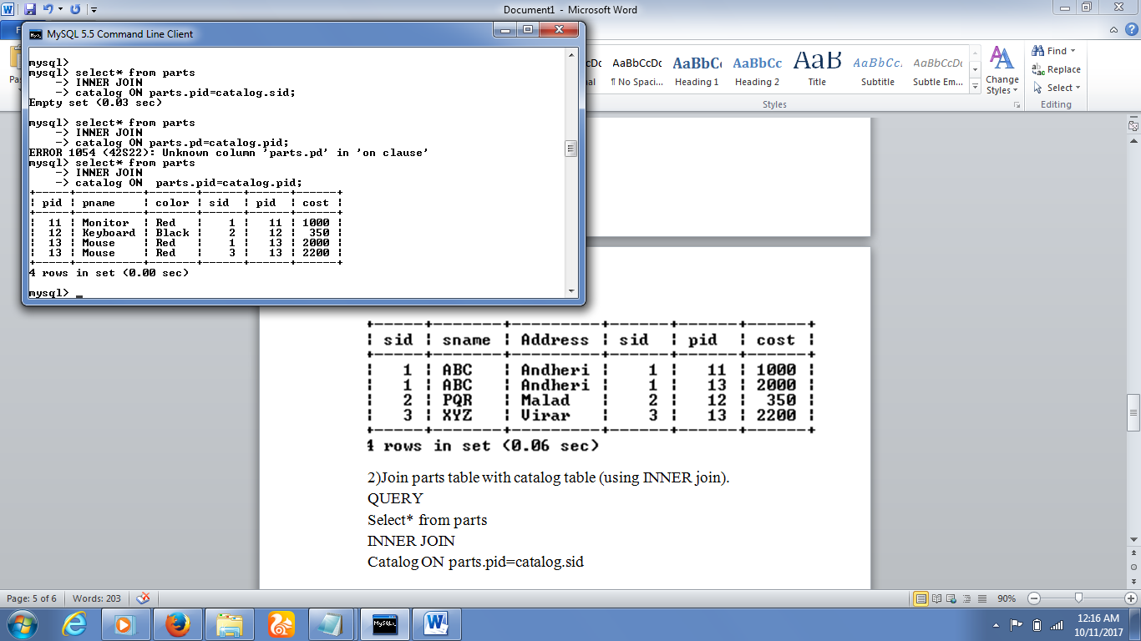3)Join parts table with supplier table.(using ad hoc relationship)

QUERY

Select* from parts INNER JOIN supplier

ON sid<=pid;

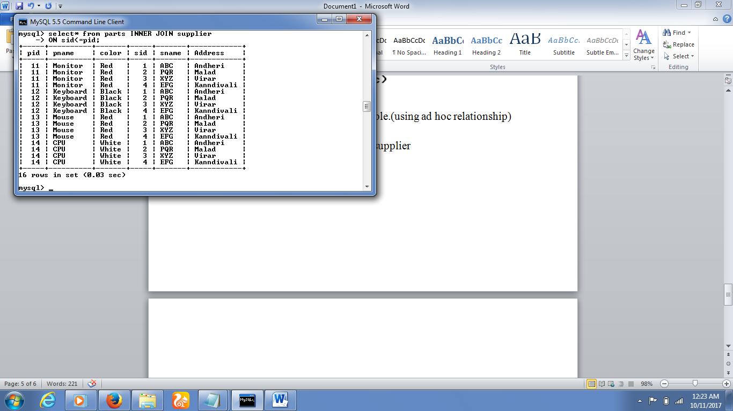

4)Join supplier,parts,catalog table.

5)Join supplier table with catalog table.(using compound join condition)

QUERY

Select*

From supplier INNER JOIN catalog

ON supplier.sid=catalog.sid OR

Supplier.sid<catalog.sid;

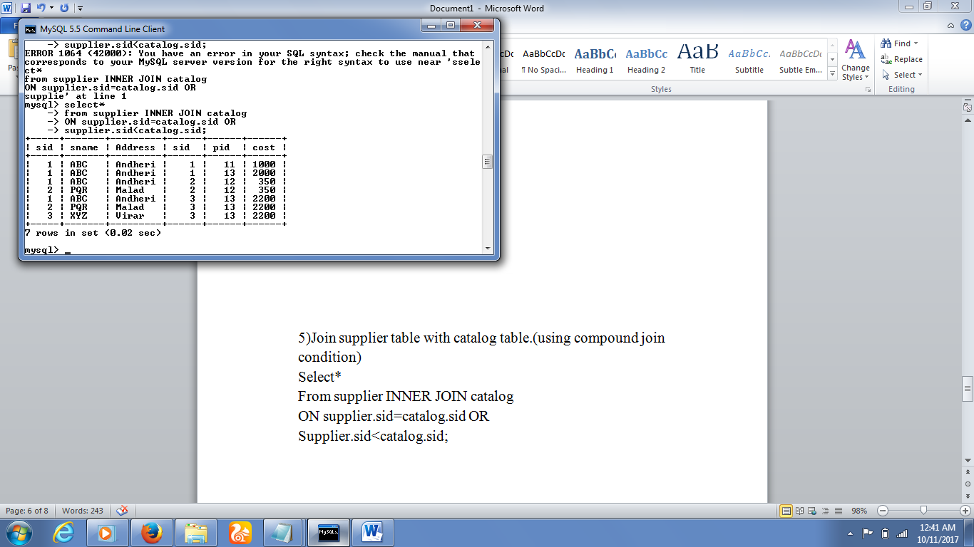

6)Join supplier table with catalog table.(using implicit INNER join syntax)

QUERY

Seelect*

Frrom supplier, catalog

Where supplier.sid=catalog.sid;

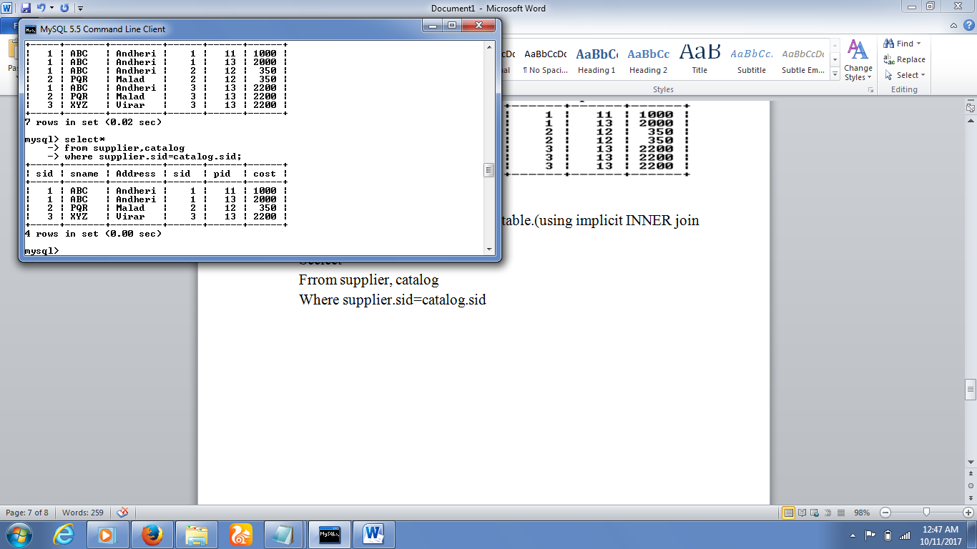7) Join supplier table with catalog table.(using LEFT OUTER join)

QUERY

Select*

From supplier LEFT OUTER JOIN catalog

ON supplier.sid=catalog.sid;

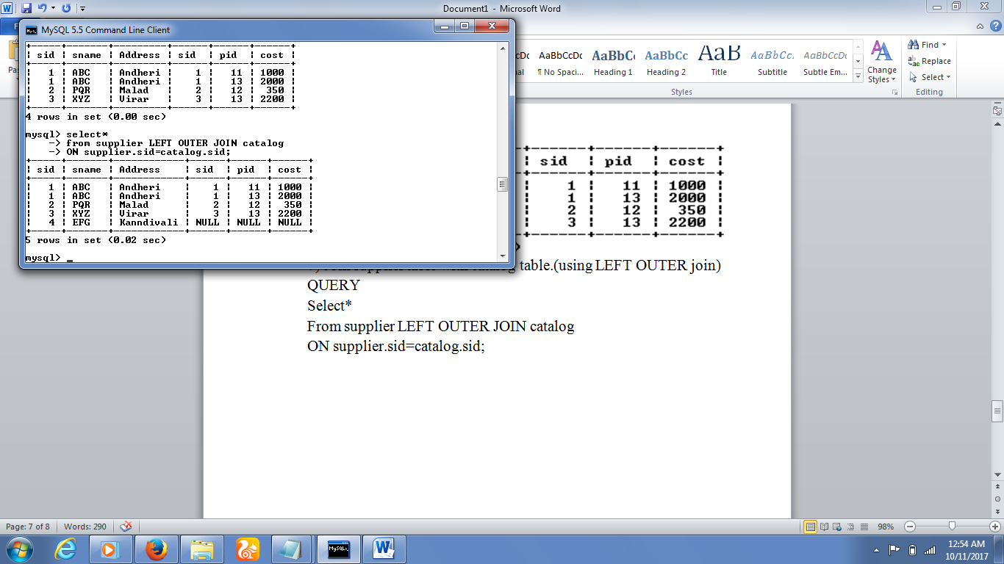

8) Join supplier table with catalog table.(using RIGHT OUTER join)

QUERY

Select*

From supplier RIGHT OUTER JOIN catalog

ON supplier.sid=catalog.sid;

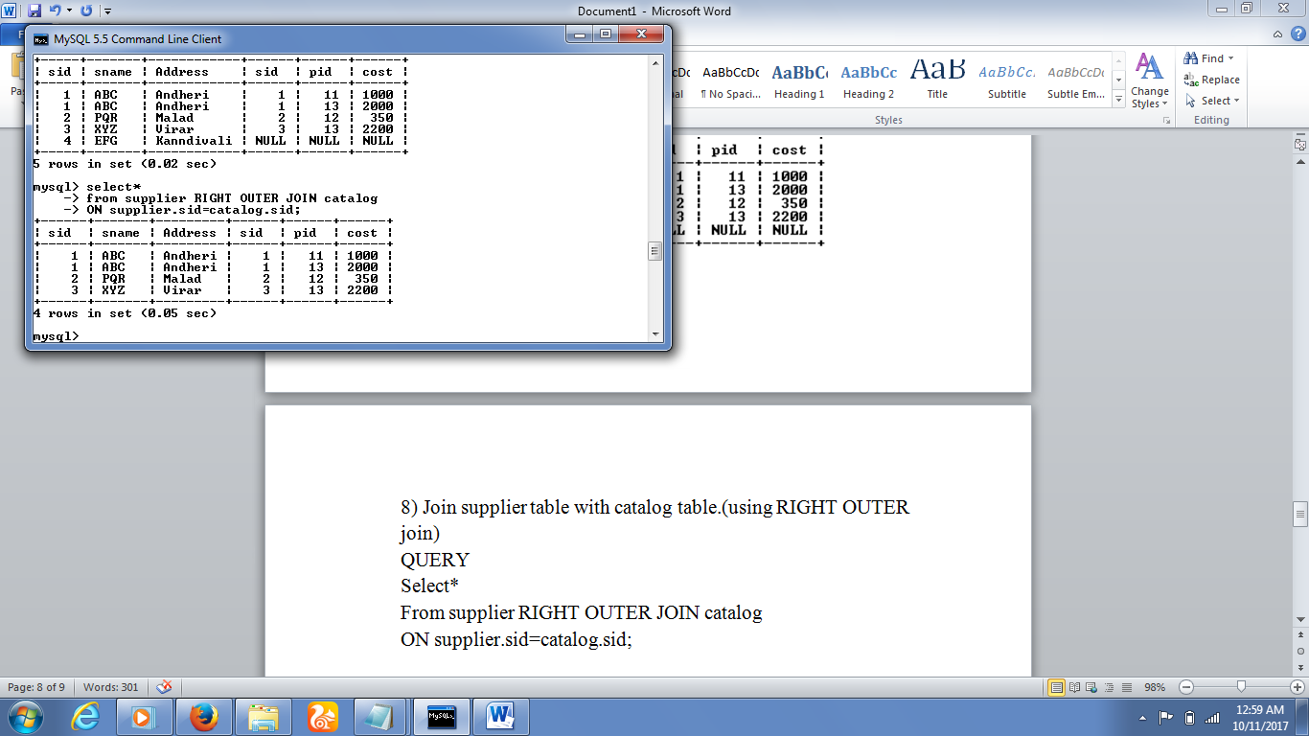

**Que No.2:-WRITE SQL QUERIES FOR THE FOLLOWING QUESTION USING JOIN.**

1)Count the number of parts supplied by sid=1

QUERY

Select count(*) from supplier INNER JOIN catalog

ON supplier.sid=catalog.sid

Where supplier.sid=1;

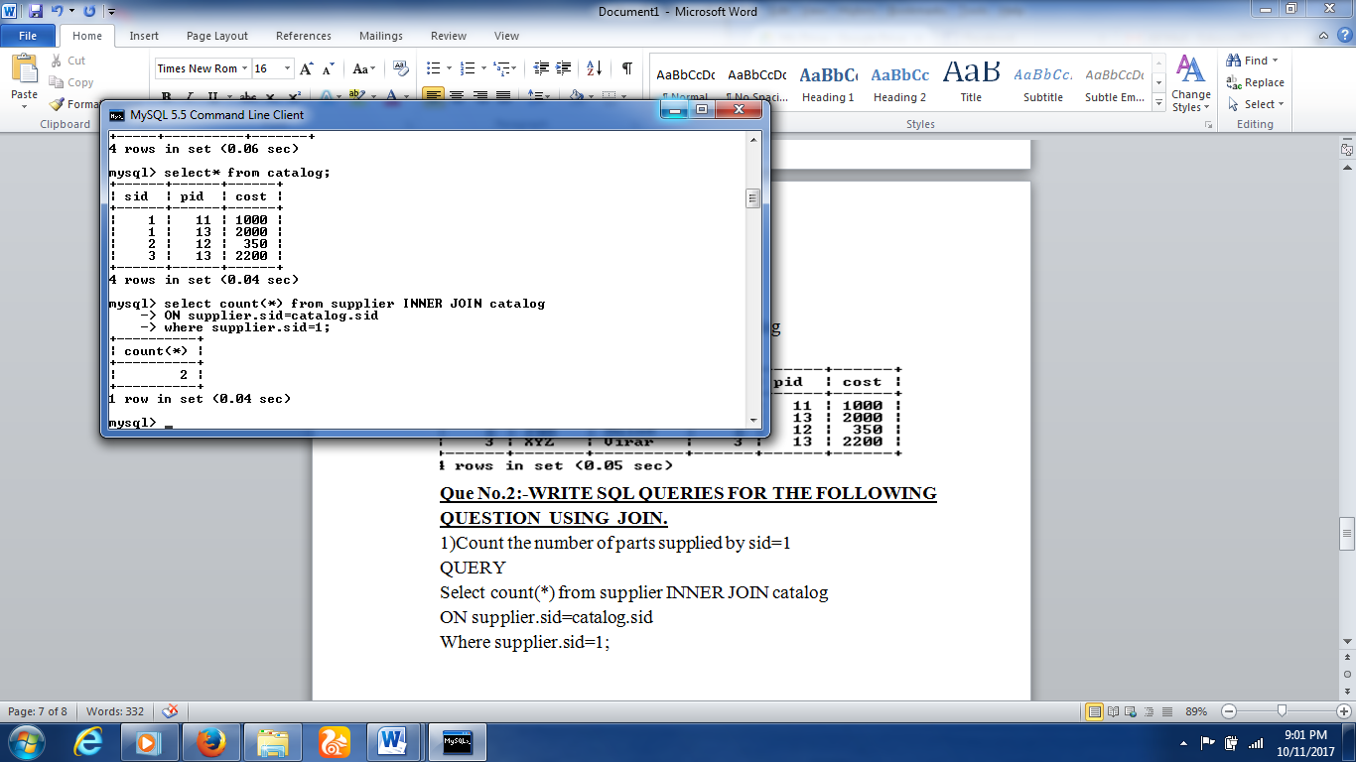

2) Find the names of supplier who supplied ‘Red’parts.

QUERY

Select distinct sname from supplier,catalog,parts

Where supplier.sid=catalog.sid AND

Parts.pid=catalog.pid AND color=’Red’;

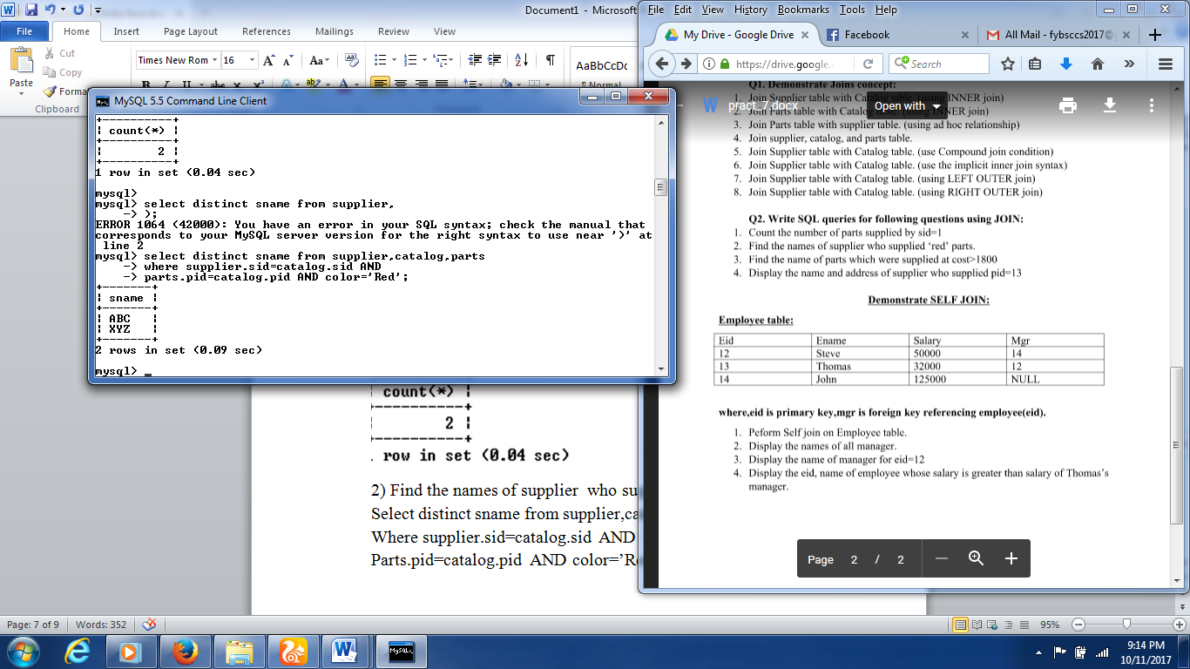  
3)Find the name of parts which were supplied at cost>1800.

QUERY

Select pname

From parts INNER JOIN catalog

ON parts.pid=catalog.pid

Where cost>1800;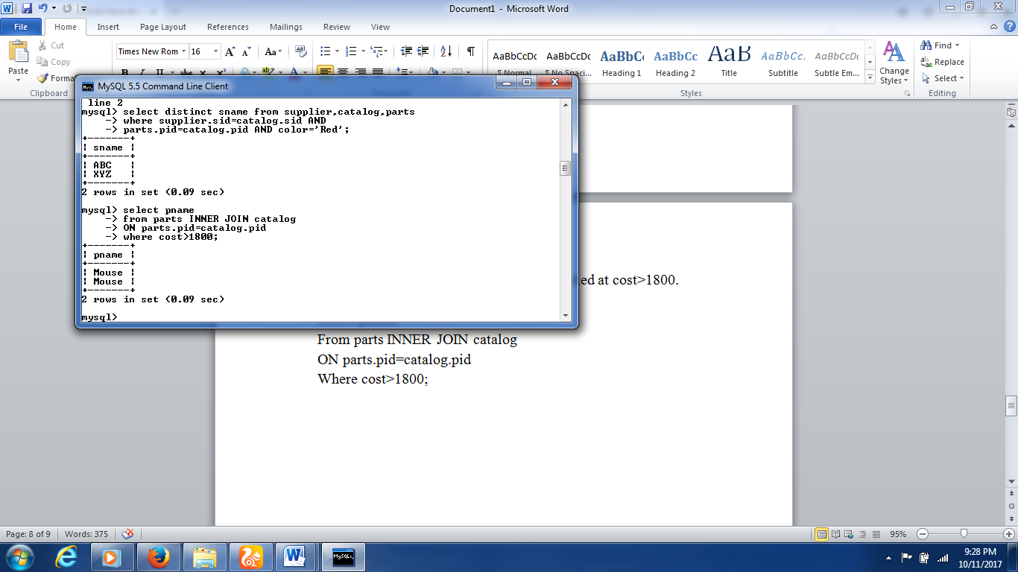

4)Display the name and address of supplier who supplied pid=13.

QUERY

Selct sname and Address

From supplier INNER JOIN catalog

**DEMONSTRATE SELF JOIN**

**Create table query**

Create table employee

(eid tinyint primary key,

ename varchar(30),

salary int,

mgr tinyint references employee(eid)

);

Table created.

**Insert query**

insert into employee values

(12,’steve’,50000,14);

1row created.

insert into employee values

(13,’Thomas’32000,12);

1row created.

insert into employee values

(14,’john’,125000,NULL);

1row created.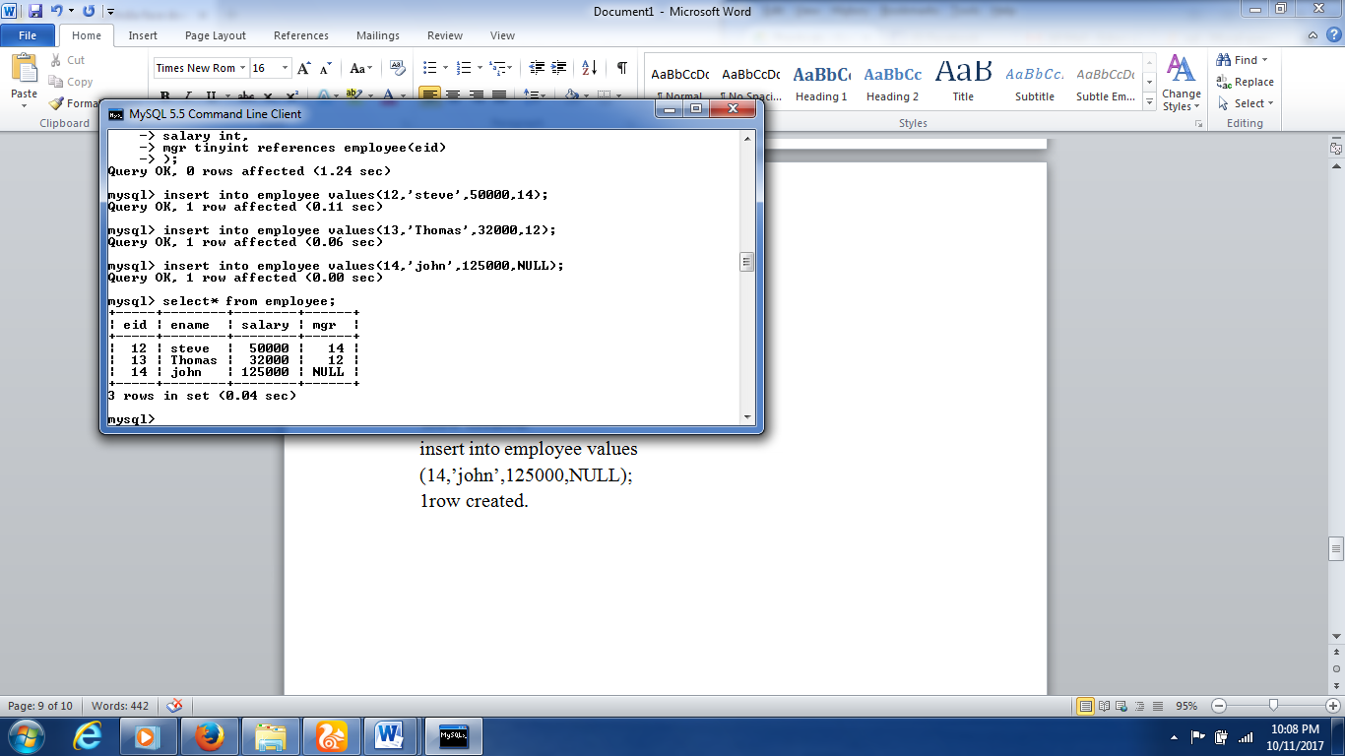

1)Perform Self join on employee table.

QUERY

Select*

from employee e1 JOIN employee e2

ON e1.eid=e2.mgr;

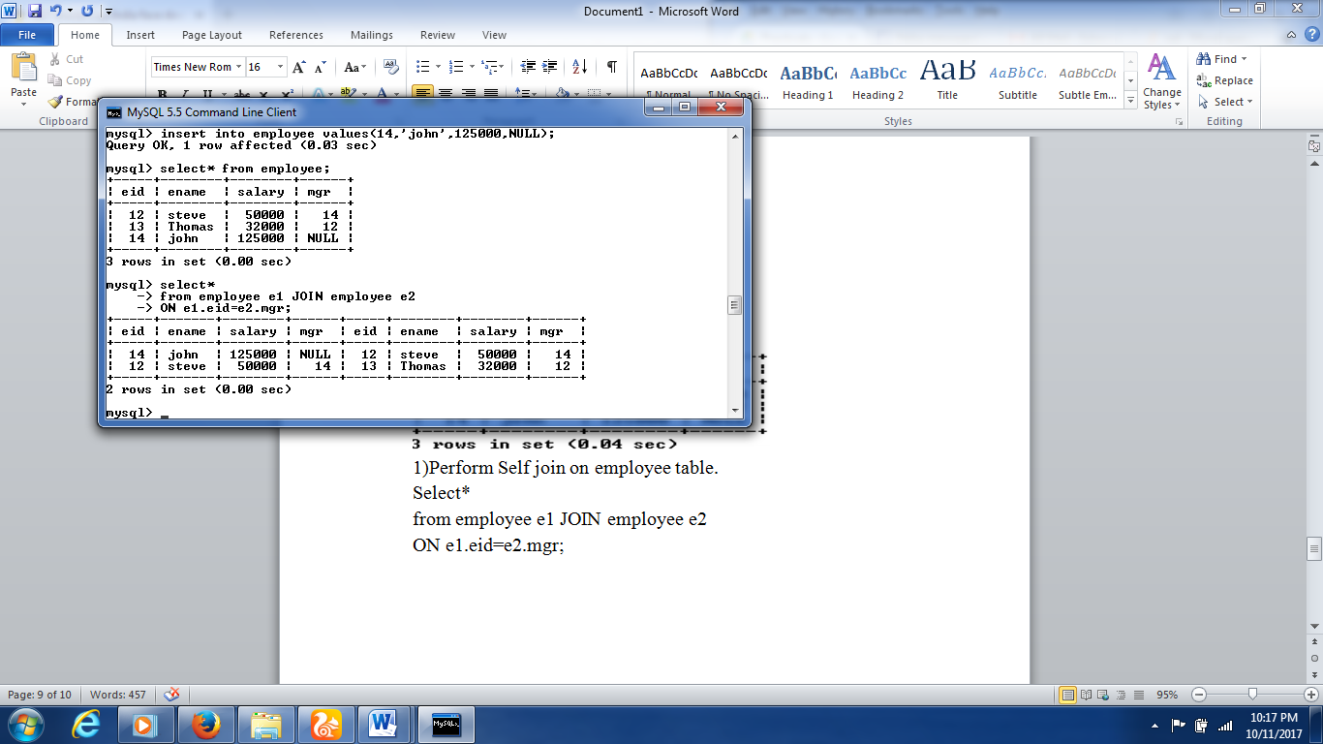

2)Display name of all managers.

QUERY

Select e1.ename

From employee e1 JOIN employee e2

ON e1.eid=e2.mgr;

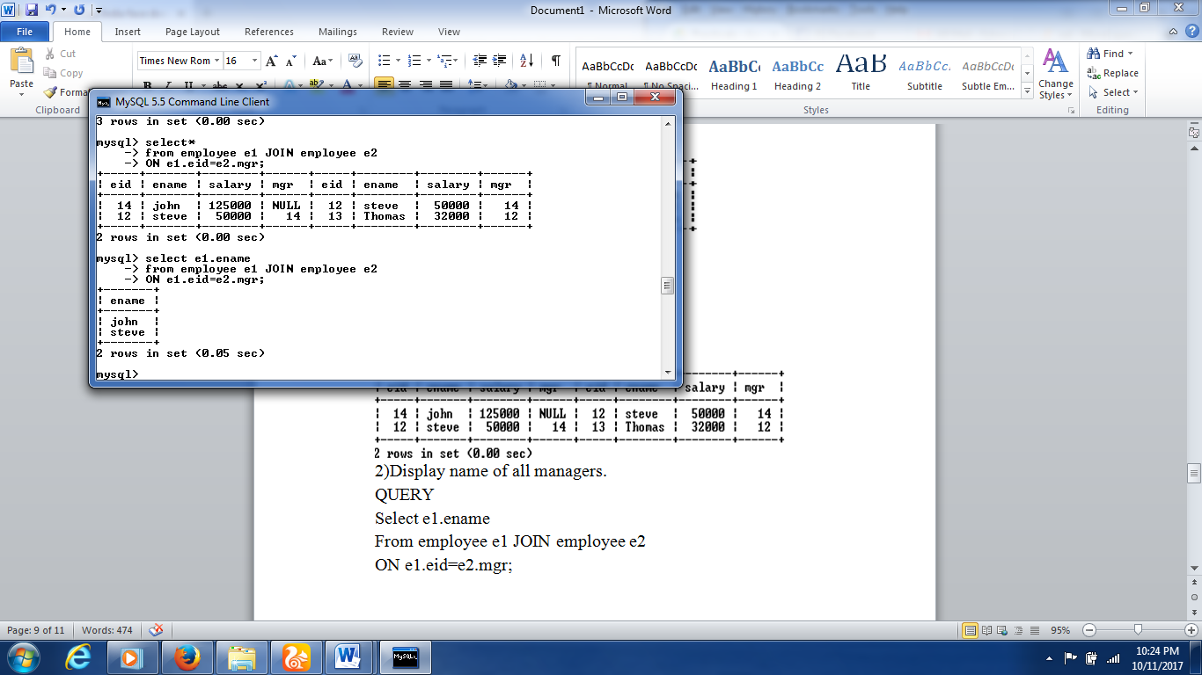

3)Display the name of manager for eid=12.

4)Display eid,name of employee whose salary is greater than salary of Thomas’s manager.